# Layout structure of bootstrap

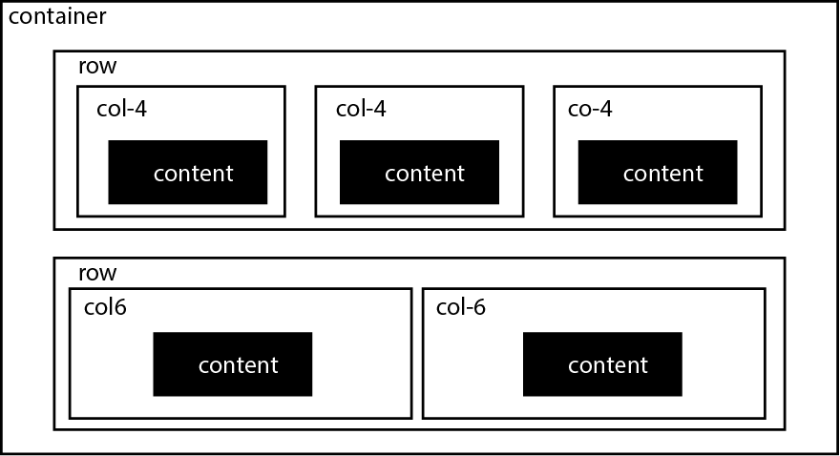

|  |
| --- |
| <div class="container">  <div class="row">  <div class="col-xs-4">  content  </div>  <div class="col-xs-4">  content  </div>  <div class="col-xs-4">  content  </div>  </div>  <div class="row">  <div class="col-xs-6">  content  </div>  <div class="col-xs-6">  content  </div>  </div>  </div> |

1. container is used to wrap the layout  
2. row is used to vertically group columns and should be inside a container  
3. col (column) is used to horizontally group content and should be inside a row

### 2. Address the 4 sizes for different devices

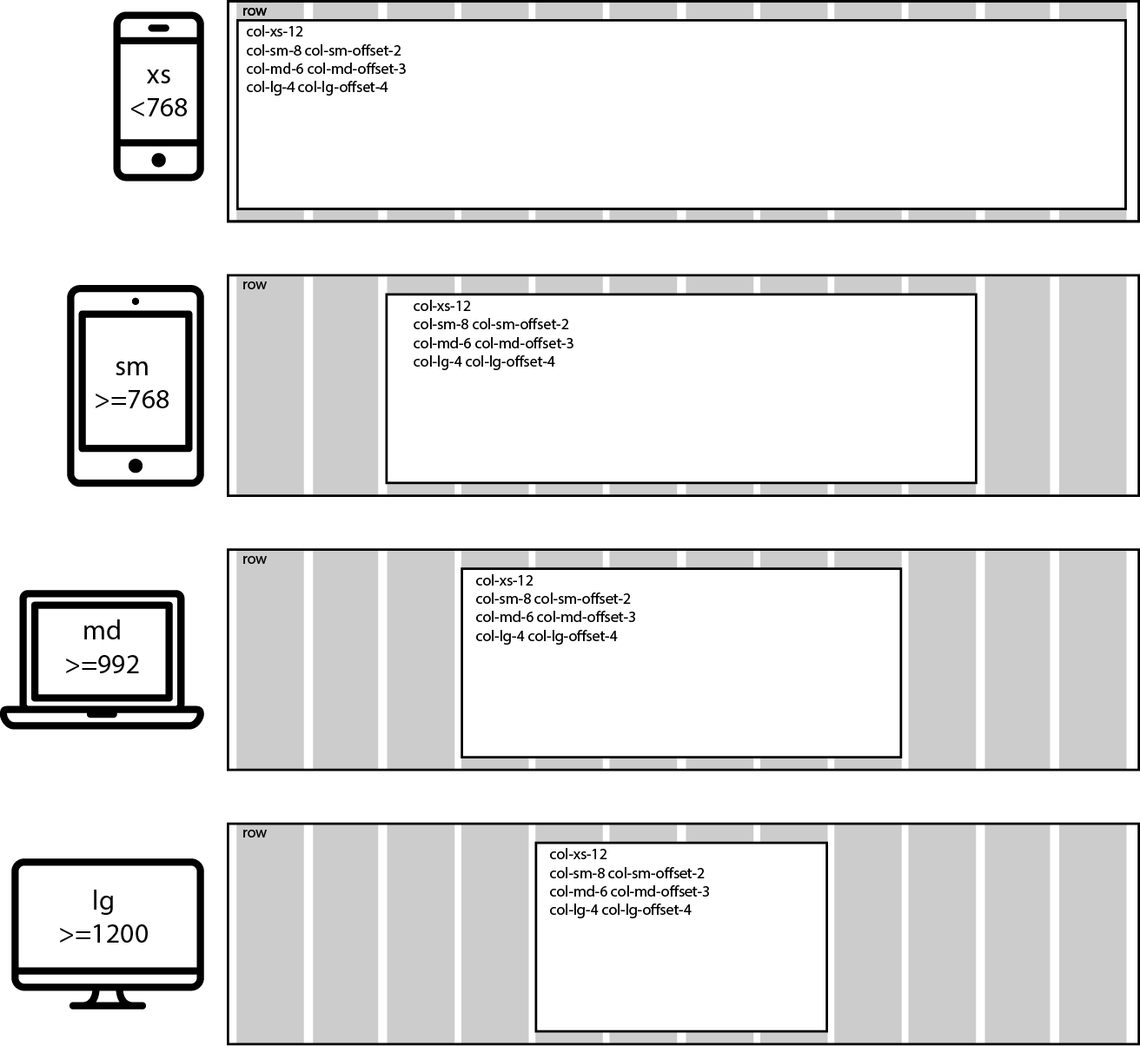

|  |
| --- |
| <div class="row">  <div class="col-xs-12  col-sm-8 col-sm-offset-2  col-md-6 col-md-offset-3  col-lg-4 col-lg-offset-4">  content  </div>  </div> |

### 3. Each <div> has 12 grids within itself

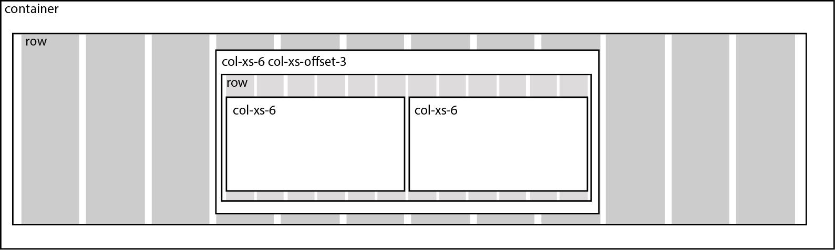

|  |
| --- |
| <div class="row">  <div class="col-xs-6 col-xs-offset-3">  <div class="row">  <div class="col-xs-6">  content  </div>  <div class="col-xs-6">  content  </div>  </div>  </div>  </div> |

1. each block element ie <div> will always have its own 12 grids

2. the safest way to create sub grids inside a col is to have another row within it

3. putting a row directly inside another row will create extra paddings which is bad

### 4. Rows with more than 12 column units will wrap

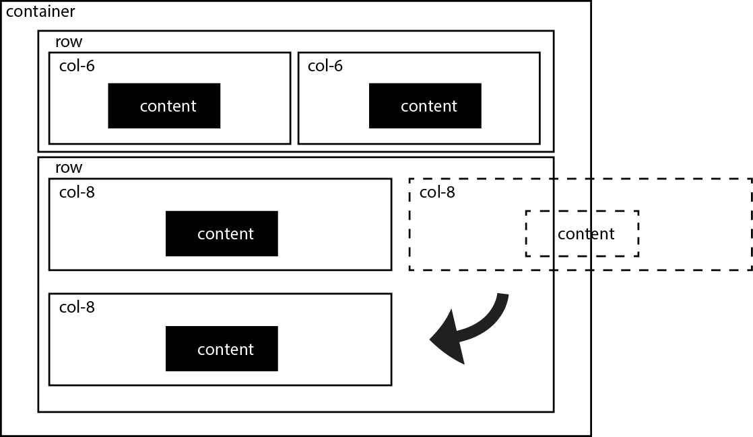

1. row only places 12 column units in one line  
2. if a row has more than 12 col units (8 + 8 = 16) the col will wrap below  
3. This concept is used for mobile responsiveness

# Building a Jumbotron

### What is a jumbotron?

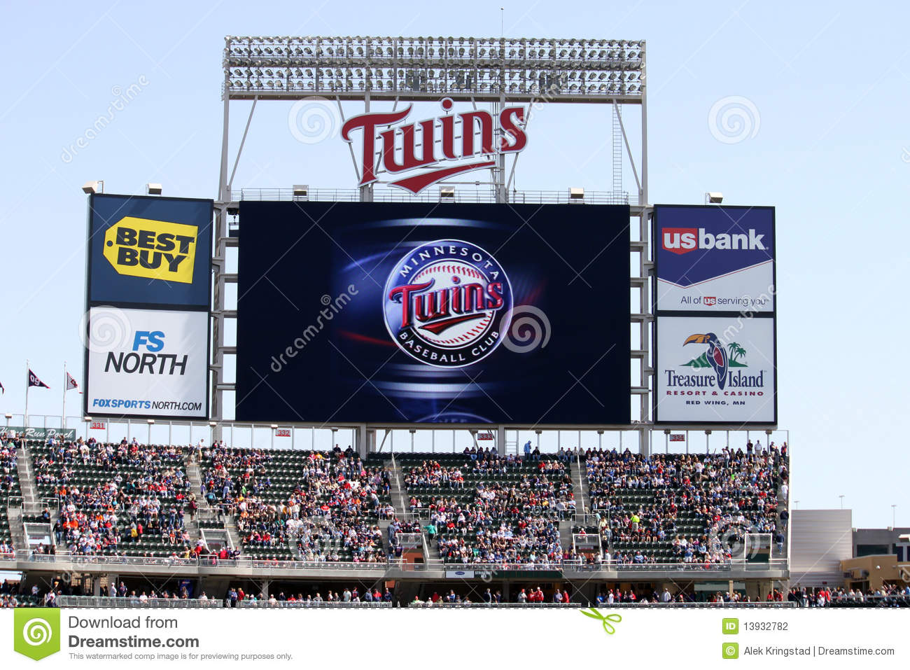

*A very large display, invented by Sony, to capture attention.*

1. Most web pages are intended to make a user do something important,

like signing up for a service. This is called a **conversion**.

2. A jumbotron is usually placed at the top of a landing page to influence the user to convert, via a **call to action.**

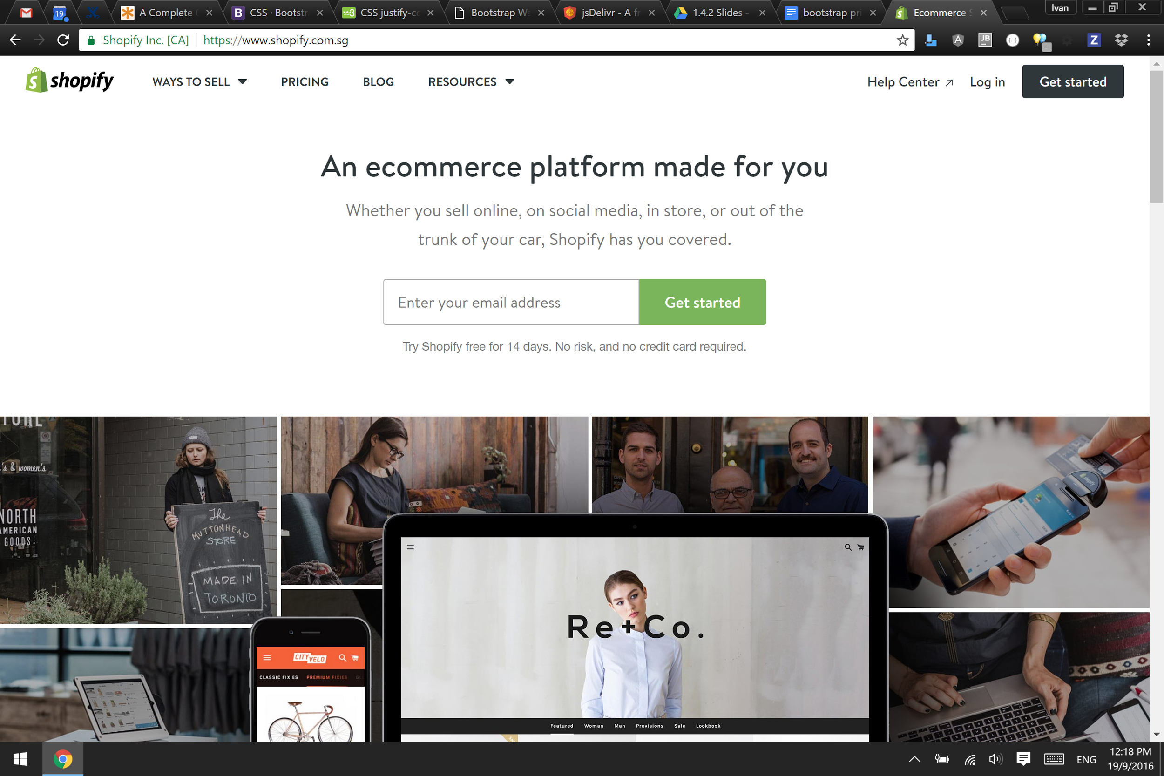

*example of shopify using a jumbotron to get users to sign up for the service*

## How to make a jumbotron

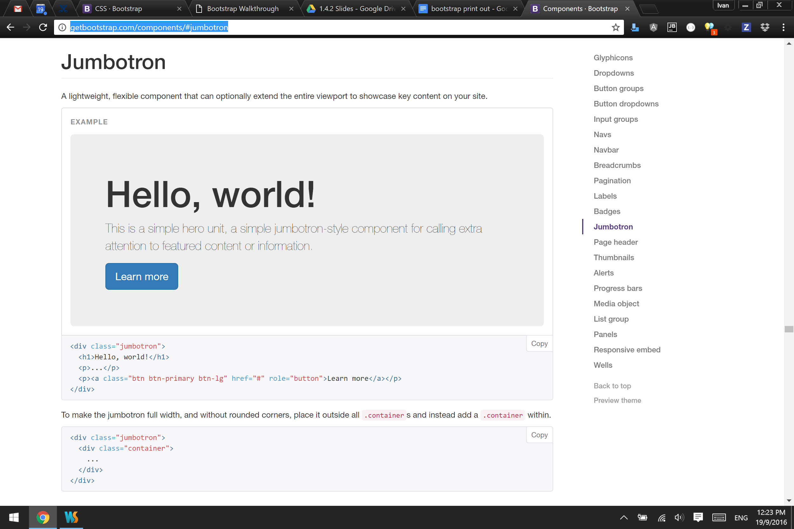

[http://getbootstrap.com/**components**/#jumbotron](http://getbootstrap.com/components/#jumbotron)

|  |
| --- |
| <!-- 1 container for the entire web page -->  <div class="container">  <!-- row 1 -->  <div class="row">  <!-- full width column on all sizes-->  <div class="col-xs-12  col-sm-12  col-md-12  col-lg-12">  <!-- JUMBOTRON- taken from: http://getbootstrap.com/components/#jumbotron -->  <div class="jumbotron">  <h1>My Big Title</h1>  <p>Some description text</p>  <p>  <a class="btn btn-primary btn-lg" href="#">  Call To Action  </a>  </p>  </div>  </div> <!-- end column -->    </div> <!-- end row -->    </div> <!-- end container --> |

Explanation of classes used

jumbotron

* creates a full width panel with a gray background
* has some padding space inside

btn

* makes the <a> have a button look

btn-primary

* gives the button a blue background color
* background-color: blue;
* Bootstrap has 7 colors for buttons
  + <http://getbootstrap.com/css/#buttons-options>
  + default - white
  + primary - blue
  + success - green
  + info - light blue
  + warning - yellow
  + danger - red
  + link - invisible button

btn-lg

* makes the button large size
* <http://getbootstrap.com/css/#buttons-options>
  + btn-lg: large
  + btn-sm: small
  + btn-xs: extra-small
  + btn-block: large and width:100%

3 panels of thumbnails

###### Small, Medium and Large screens

row

col-sm-4

col-md-4

col-lg-4

col-sm-4

col-md-4

col-lg-4

col-sm-4

col-md-4

col-lg-4

###### Extra small screens

row

col-xs-12

col-xs-12

col-xs-12

|  |
| --- |
| <!-- row 2 -->  <div class="row">  <!-- column 1-->  <div class="col-xs-12  col-sm-4  col-md-4  col-lg-4">  </div> <!-- end column 1 -->    <!-- column 2-->  <div class="col-xs-12  col-sm-4  col-md-4  col-lg-4">  </div> <!-- end column 2 -->  <!-- column 3-->  <div class="col-xs-12  col-sm-4  col-md-4  col-lg-4">  </div> <!-- end column 3 -->  </div> <!-- end row --> |

|  |  |
| --- | --- |
| THUMBNAIL [http://getbootstrap.com/components/](http://getbootstrap.com/components/#thumbnails-custom-content)  [#thumbnails-custom-content](http://getbootstrap.com/components/#thumbnails-custom-content) |  |

|  |
| --- |
| <!-- column 1-->  <div class="col-xs-12  col-sm-4  col-md-4  col-lg-4">  <!-- THUMBNAIL: http://getbootstrap.com/components/#thumbnails-custom-content -->  <div class="thumbnail">  <img src="http://placehold.it/800x600" alt="" class="img-responsive">  <div class="caption">  <h3>Thumbnail label</h3>  <p>  Lorem ipsum dolor sit amet, consectetur adipisicing elit.  </p>  <a href="#" class="btn btn-primary">Button</a>  </div>  </div>  </div> <!-- end column 1 --> |

##### Explanation of classes used

thumbnail

* creates a panel with
  + width: 100%
  + border

img-responsive : <http://getbootstrap.com/css/#images-responsive>

* display: block
* max-width: 100%
* it makes the image scale to fit parent div

caption

* adds margin

**! After finishing the row of thumbnails, add a <hr> to make a dividing line**

Large Video

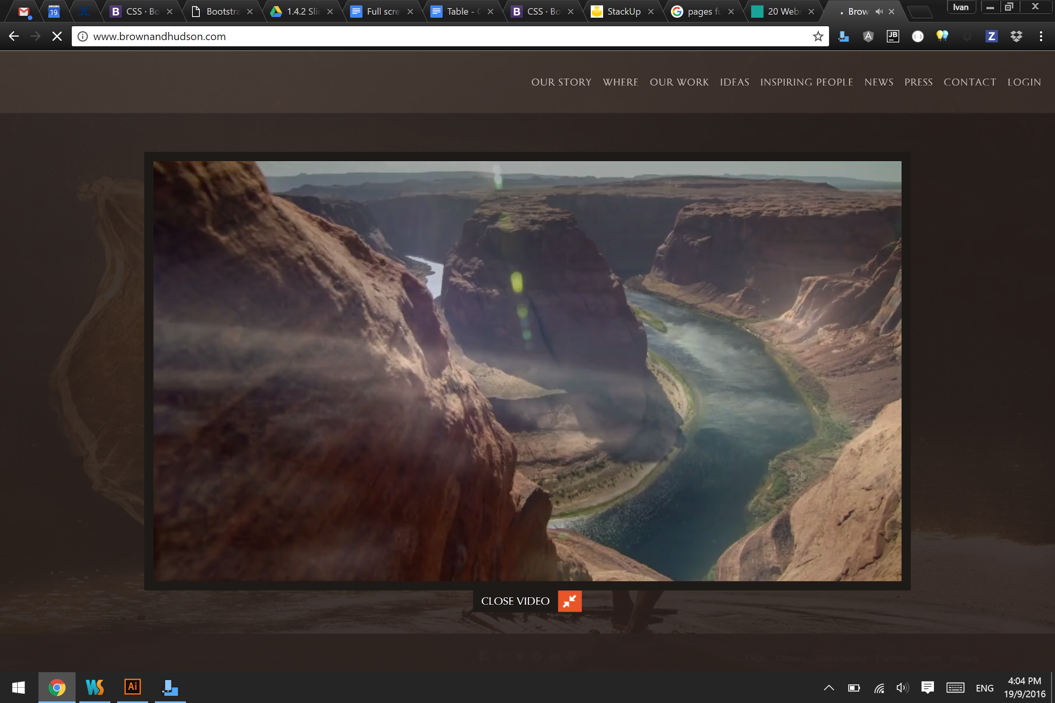

*Image from brown and hudson - bespoke travel*

Websites that sell and experience tend to use full screen videos to engage readers. Since this is a common feature, bootstrap has a class for it too.

row

col-xs-12

col-sm-12

col-md-12

col-lg-12

### How it works

1. In web pages, **embed** means **loading external content**, like:
   * external video
   * music player
   * interactive applications
2. Another similar concept is the **<iframe>**
   * which **loads another window within the page**.
   * Common scenarios for using <iframe> are:
     + Google maps
     + Youtube videos
     + Slide Share
3. **Aspect ratio** is the ratio of your device's screen **width : height**
4. Typically, online videos come in 2 aspect ratios:
   * **4:3** is the boxish screen of old TVs (old shows are like this)
   * **16:9** is the screen of modern day TVs (newer shows are like this)
5. Youtube videos come in 16:9. So we will make our iframe scale with the screen in this ratio using bootstrap.

Step 1: Create the layout

1. Create a row
2. Create a full width column - 12 grids
3. Make the column 'embed responsive' with these 2 steps:
   1. Enable responsiveness with the class: embed-responsive
      1. This makes the embed-responsive-item item inside the div scale nicely
   2. Choose between 16:9 or 4:3
      1. 16by9: embed-responsive-16by9
      2. 4by3: embed-responsive-4by3

Step 2: Add the <iframe> video content

1. Within the embed-responsive <div>, add an <iframe> inside
   1. The syntax is <iframe src="..."></iframe>
   2. 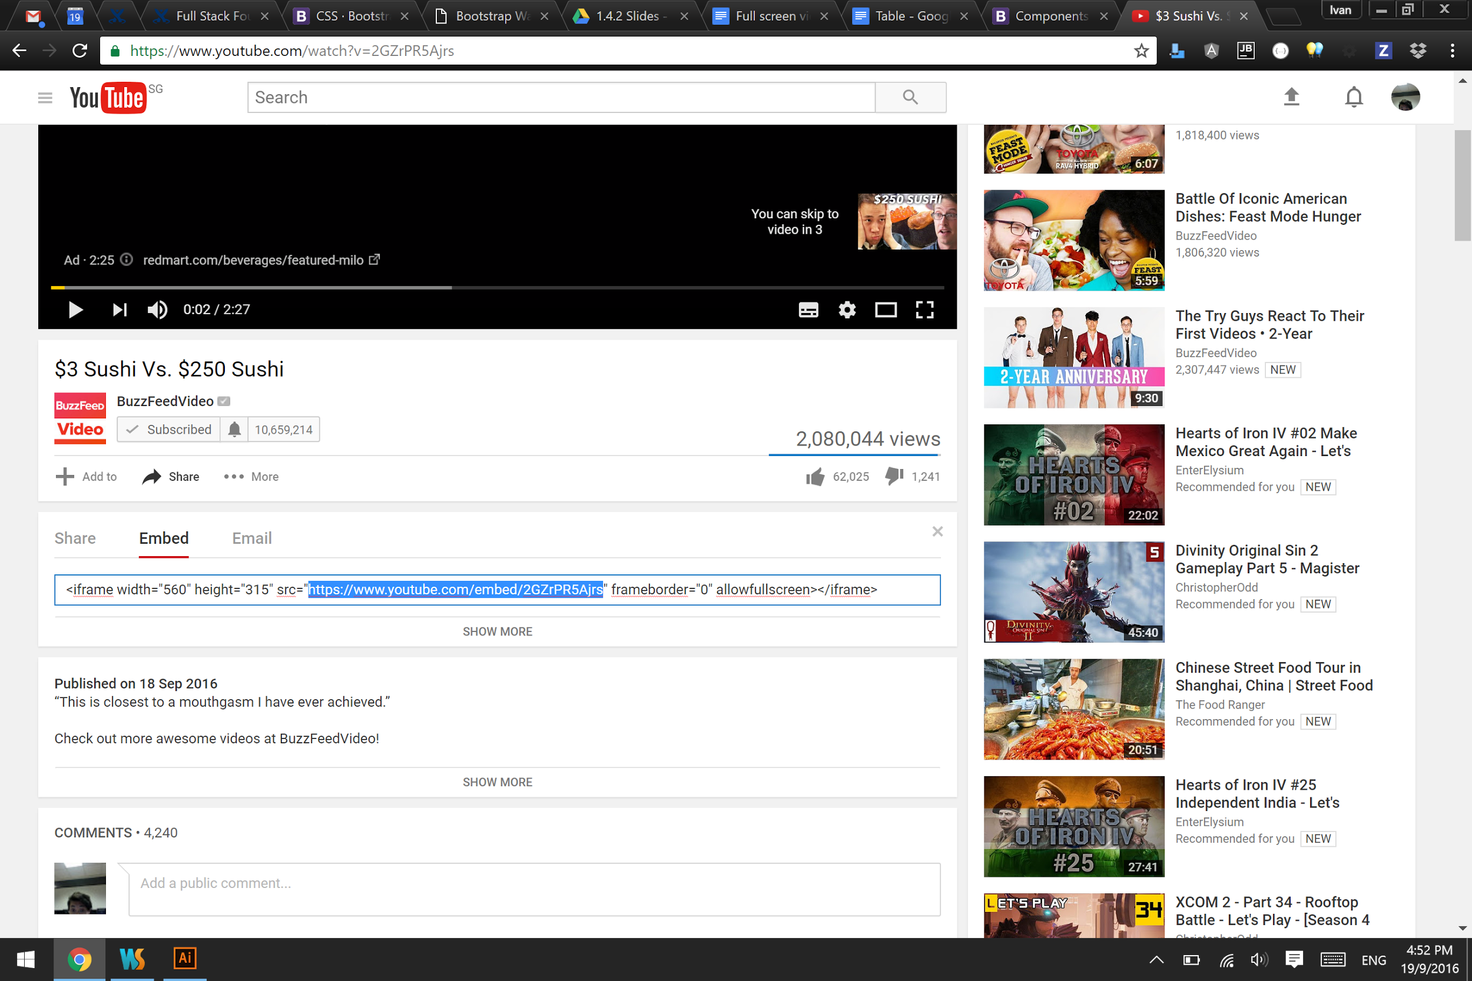  
      On the youtube page, click: share > embed  
      get the url from the iframe code (highlighted above).
   3. To let bootstrap know that this is the element we want to make responsive add the class: embed-responsive-item

|  |
| --- |
| <!-- row 3 -->  <div class="row">  <!-- full width column on all sizes-->  <div class="col-xs-12  col-sm-12  col-md-12  col-lg-12">  <!-- responsive video -->  <div class="embed-responsive embed-responsive-16by9">  <iframe class="embed-responsive-item"  src="https://www.youtube.com/embed/mpDOscUDQ_0"></iframe>  </div>  </div> <!-- end column -->  </div> <!-- end row --> |

**! After finishing the row of thumbnails, add a <hr> to make a dividing line**

# FORM

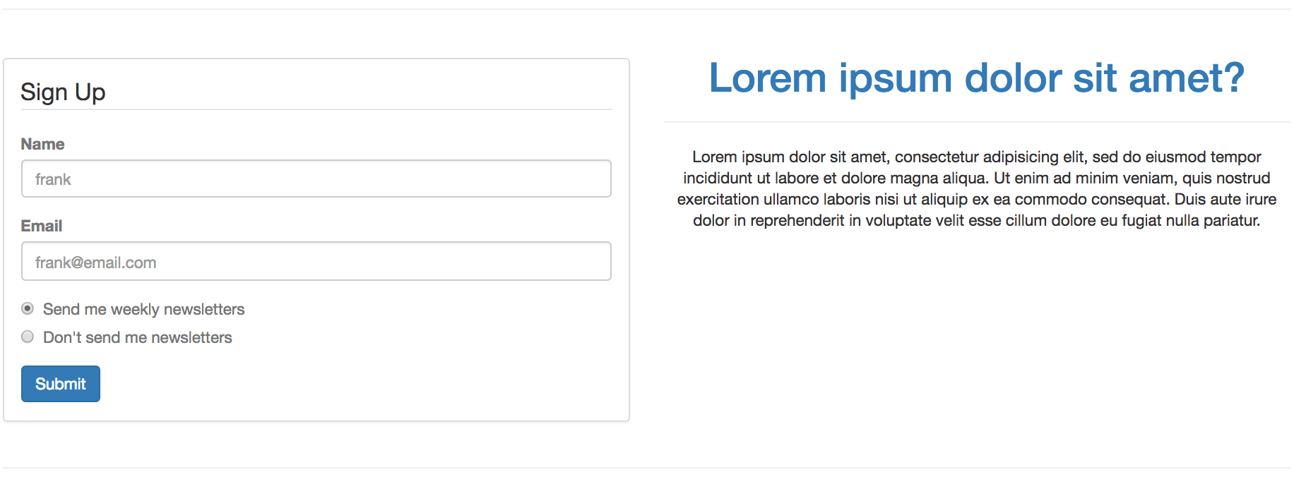

row

col-xs-12

col-sm-6

col-md-6

col-lg-6

col-xs-12

col-sm-6

col-md-6

col-lg-6

|  |
| --- |
| <!-- row 4 -->  <div class="row">  <!-- column for form -->  <!-- full width on xs screen. half the screen on all other sizes-->  <div class="col-xs-12  col-sm-6  col-md-6  col-lg-6">  </div> <!-- end column -->  <!-- column for text -->  <!-- full width on xs screen. half the screen on all other sizes-->  <div class="col-xs-12  col-sm-6  col-md-6  col-lg-6">  </div> <!-- end column -->  </div> <!-- end row |

### 

### Steps To creating a panel

Create a Panel to contain the form (put a border around it)

<http://getbootstrap.com/components/#panels-basic>

|  |
| --- |
| <div class="panel panel-default text-muted">  <div class="panel-body">  <!-- FORM WILL GO INSIDE HERE -->  </div>  </div> |

1. Create a <div> with class "panel panel-default text-muted"

* panel
  + creates a box with a border
* panel-default
  + white color panel
  + Other colors are: (<http://getbootstrap.com/components/#panels-alternatives>)
    - panel-primary: blue
    - panel-success: green
    - panel-info: light-blue
    - panel-warning: yellow
    - panel-danger: red
* text-muted
  + makes the text color gray
  + Other colors are: (<http://getbootstrap.com/css/#helper-classes-colors>)

2. Inside panel, create another <div> with class "panel-body"

* panel-body
  + adds margins for nice layout
  + Form will go inside here

### How forms work

<http://getbootstrap.com/css/#forms>

1. In bootstrap, forms have a standard structure
   1. The entire form is wrapped in the <form></form> as usual
   2. To name the form, we use <legend>signup</legend>
      1. Legend is also a HTML syntax to specifically name forms
   3. Each form section has to be grouped for proper styling
      1. So far we have typically created each <input> to pair with a <label>
      2. This pairing has to be grouped into a <div class="form-group">
      3. Within the form-group the input is classed as form-control

|  |
| --- |
| <div class="**form-group**">  <label> ... </label>  <input class="**form-control**">  </div> |

1. Forms are width 100% in bootstrap.
   1. The proper way to limit the width is to use columns.

### Bootstrapping a form style

Start with the basic form for Name, Email and Submit

|  |
| --- |
| <form action="https://coderinyou-1332.appspot.com/submit" method="post">  <div>  <label for="name-id">Name</label>  <input type="text"  name="name"  id="name-id"  placeholder="frank">  </div>  <div>  <label for="email-id">Email</label>  <input type="email"  name="email"  id="name-id"  placeholder="frank@email.com">  </div>  <input type="submit">  </form> |

1. We want to give the form a title. In conventional HTML, titles specifically for forms don't use <h1>. Instead we use <legend>. Add a legend into the form:

|  |
| --- |
| <form action="https://coderinyou-1332.appspot.com/submit" method="post">  **<legend>Sign Up</legend>** |

2. We want to add margins to each <div> section of the form to give a nice spacing. To achieve this, we add to the <div> a bootstrap class called "**form-group**"

|  |
| --- |
| <div class="**form-group**"> |

3. Next we want to style the <input> to fill the width of the form. To achieve this, we add to the <input> a bootstrap class called "**form-control**"

|  |
| --- |
| <input class="**form-control**" .......> |

4. Finally we want to style the submit button to look like a bootstrap button. For this, we can use the same "btn" class like in the jumbotron exercise.

|  |
| --- |
| <input type="submit" class="btn btn-primary"> |

### Radio buttons the bootstrap way

###### Basic HTML radio buttons

Radio inputs Use Name and Value, similar to other input types. The purpose of a radio button is to give the option of different values to one key: { "gender" : "male" }

So the name="..." in each radio button is the same, But the value=".." is different.

|  |
| --- |
| <input type="radio" name="gender" value="male"> Male  <input type="radio" name="gender" value="female"> Female |

###### Bootstrap radio

Instead of using the <label for="id"> strategy to bind the text to the input, Bootstrap requires us to do it in a slightly less accurate way, because of styling limitations. This time, we wrap the <label> around BOTH the <input> and the text, instead of just the text. This allows us to click on the text to :focus onto the input too.

|  |
| --- |
| <div class="radio">  <label>  <input type="radio" name="gender" value="male">Male  </label>  </div> |

To put it all together, a newsletter radio button will look like this:

|  |
| --- |
| <div class="form-group">  <div class="radio">  <label>  <input type="radio"  name="newsletter"  value="weekly"  checked="checked">  Send me weekly newsletters  </label>  </div>  <div class="radio">  <label>  <input type="radio"  name="newsletter"  value="never">  Don't send me newsletters  </label>  </div>  </div> |

### General Text

General text in bootstrap works without the need of adding class names.

If we want to centeralise text with text-align CSS, there is a helper class that lets us do that

<http://getbootstrap.com/css/#type-alignment>

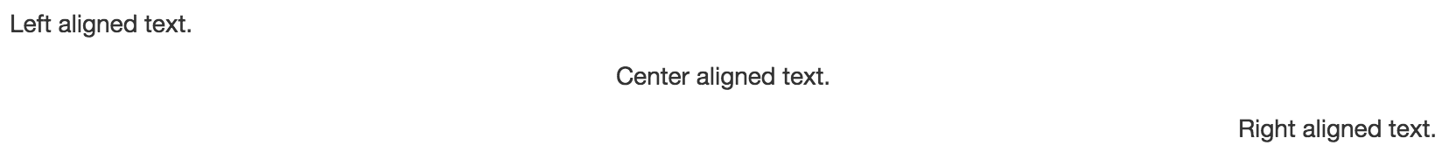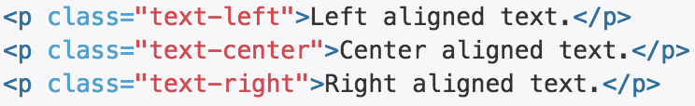

|  |
| --- |
| <div class="col-xs-12 col-sm-6 **text-center**">    <h1 class="text-primary">Lorem ipsum dolor sit amet?</h1>  <hr>  <p>Lorem ipsum...</p>  </div> |

**! After finishing the row of thumbnails, add a <hr> to make a dividing line**

3 panels of contact information

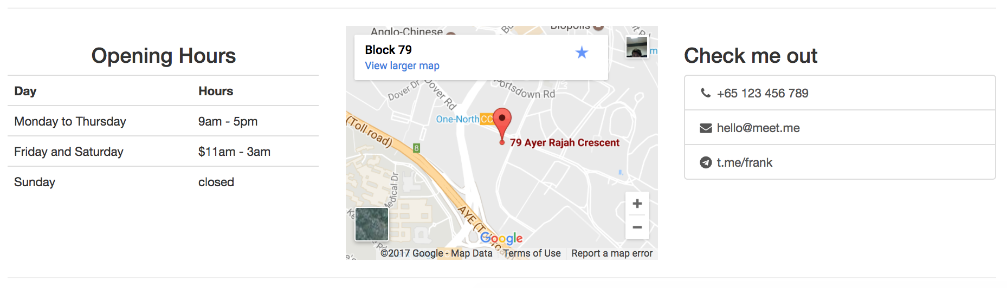

The row and column structure is the same a the 3 thumbnails exercise. Test your understanding by recreating the row independently.

### Table

Assume we have a regular HTML table, like the one in the HTML exercise before.

|  |
| --- |
| <table>  <tr>  <th>Day</th>  <th>Hours</th>  </tr>  <tr>  <td>Monday to Thursday</td>  <td>9am - 5pm</td>  </tr>    <tr>  <td>Friday and Saturday</td>  <td>$11am - 3am</td>  </tr>    <tr>  <td>Sunday</td>  <td>closed</td>  </tr>  </table> |

To bootstrap the table, simply add the class "table" to the table

<http://getbootstrap.com/css/#tables-example>

|  |
| --- |
| <table class="table"> |

### 

### 

### Google Maps Embed

The google maps feature is an <iframe> embed, exactly like the youtube video.

|  |
| --- |
| <div class="embed-responsive embed-responsive-4by3">  <iframe src="..." class="responsive-embed"></iframe>  </div> |

To put in maps instead of youtube, we only need to change the url in src="..." . To get the URL we want,

1. Find the address on Google Maps and click the share button.
2. In the share window,
   1. select the Embed tab
   2. Get the URL
   3. 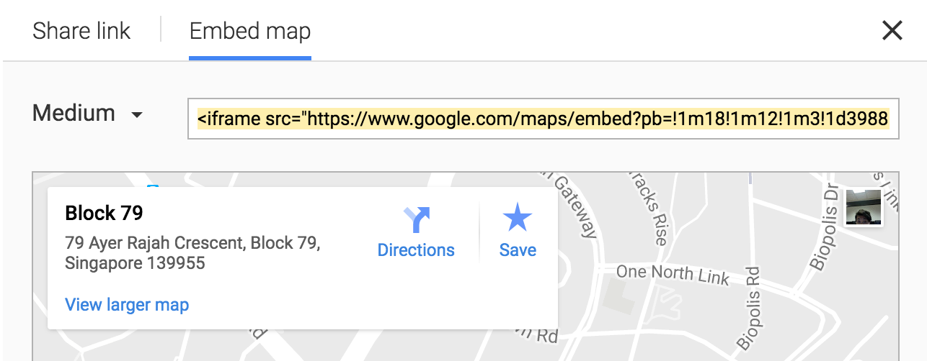

It should look like this:

|  |
| --- |
| <iframe src="**https://www.google.com/maps/embed?pb=!1m18!1m12!1m3!1d3988.7945178937484!2d103.78528081585408!3d1.2980111990533032!2m3!1f0!2f0!3f0!3m2!1i1024!2i768!4f13.1!3m3!1m2!1s0x31da1a4fe45692e5%3A0xc90d9ee9e29fd8c2!2s79+Ayer+Rajah+Crescent%2C+Block+79%2C+Singapore+139955!5e0!3m2!1sen!2ssg!4v1484071330822**" width="600" height="450" frameborder="0" style="border:0" allowfullscreen></iframe> |

The URL in the src=".." is what we want. You can optionally shorten it with goo.gl

### 

### 

### List

<http://getbootstrap.com/components/#list-group-basic>

|  |  |
| --- | --- |
|  | To bootstrap a list, simply add the class "list-group" to the <ul>unordered list and "list-group-item" to all the <li>list items. |

To use font awesome icons in this scenario, we will be using a list group instead of the previously used list icon.

<http://fontawesome.io/examples/#fixed-width>

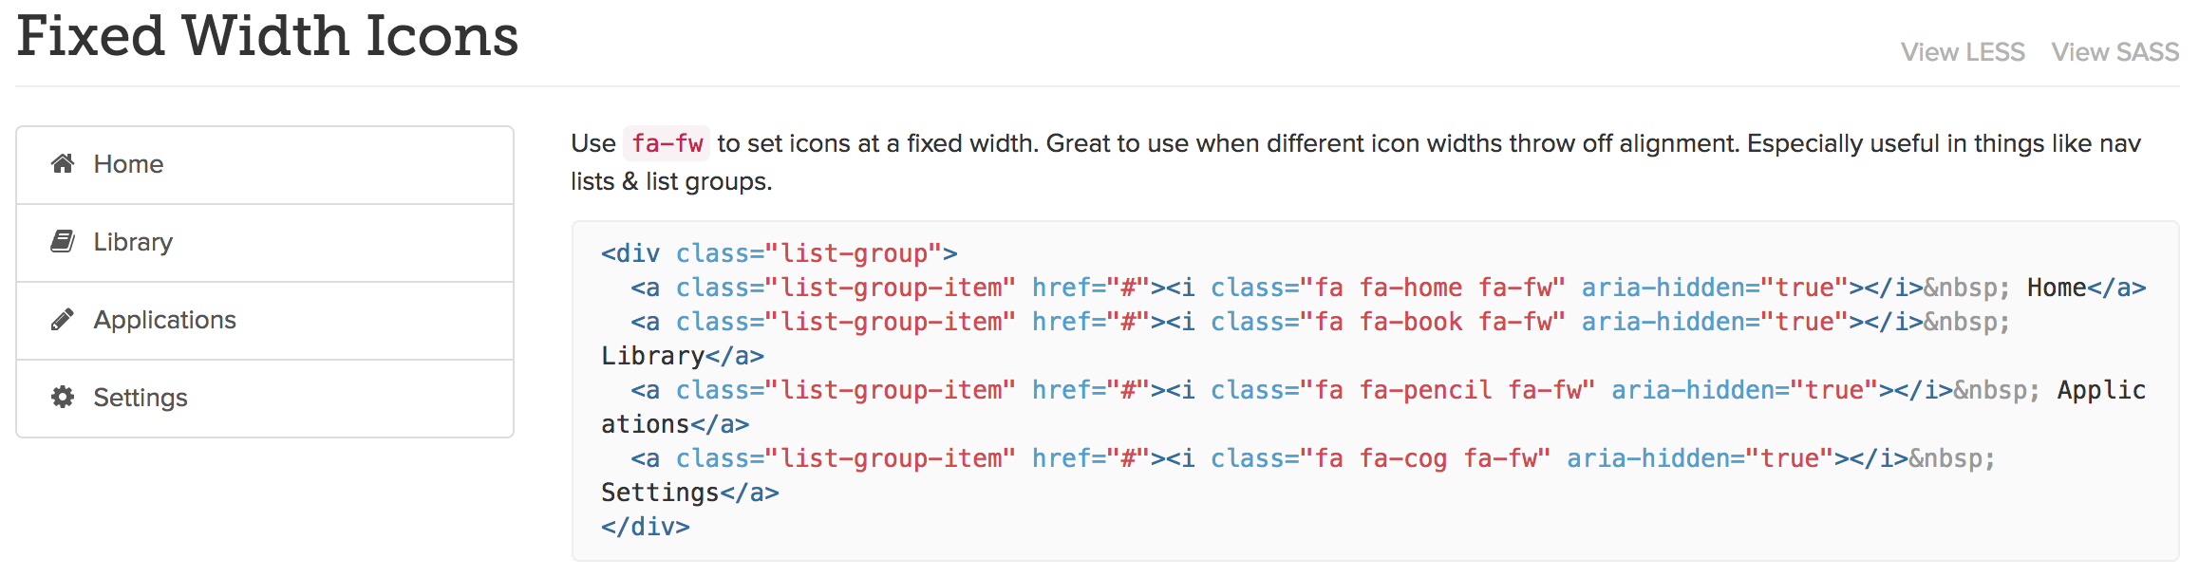

The icon to add will look like this

|  |
| --- |
| <i class="fa fa-phone fa-fw"> |

Expected outcome example

|  |
| --- |
| <div class="list-group">  <a href="#" class="list-group-item">  <i class="fa fa-phone fa-fw"></i> +65 123 456 789  </a>  <a href="#" class="list-group-item">  <i class="fa fa-envelope fa-fw"></i> [hello@meet.me](mailto:hello@meet.me)  </a>  </div> |

Test your understanding. Create the last row of social media icon links using bootstrap and font awesome.

Hint 1: horizontal spacing - <http://getbootstrap.com/css/#inline>

Hint 2: horizontal centering - <http://getbootstrap.com/css/#type-alignment>

# Using Themes

Look at line 10 of your code. Some CSS themes are provided for you to try.

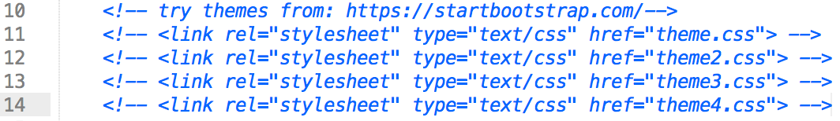

To get more themes, go to : <https://bootswatch.com/>

|  |  |
| --- | --- |
| How to use Click download > bootstrap.css  A css fill will open in your browser. Create a new CSS file in your project folder and paste the code in.  Save it and add the CSS link into your html document. |  |

# Using animations

The setup has been done for you. The setup was done by adding the CDN link for animate.css <https://cdn.jsdelivr.net/animatecss/3.5.2/animate.min.css> to the <head>

and wow.js <https://cdn.jsdelivr.net/wow/1.1.2/wow.min.js> at the end of the web page.

|  |  |
| --- | --- |
| HOW TO USE:  Go to <https://daneden.github.io/animate.css/> and choose an animate you like. eg. "bounce"  Add the class to any item you want to animate and also add "wow" |  |
| <img src=" ... " class="**wow bounce**"> | |